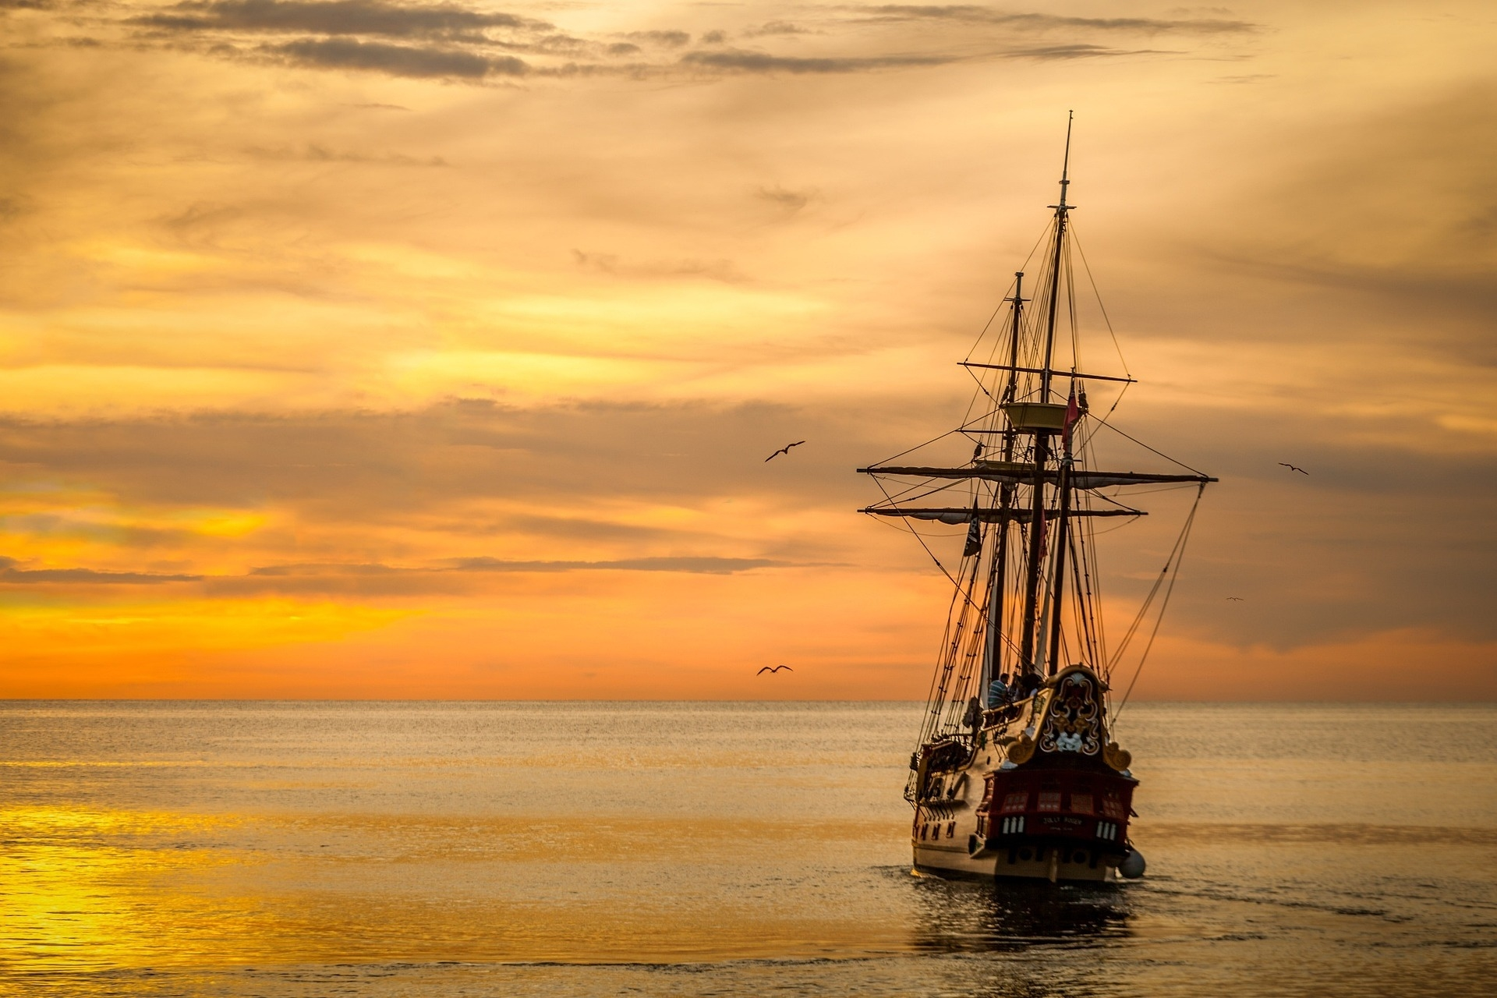

**LET**

**YOUR**

**DREAMS**

**SAIL**

THE SAILING ODYSSEY

TABLE OF CONTENTS

|  |  |
| --- | --- |
| **CONTENTS** | **PAGE NO.** |
| INTRODUCTION | 3 |
| PROJECT GRAPHS | 6 |
| LIST OF OBJECTS | 8 |
| LIST OF FUNCTIONS | 10 |
| LIST OF ANIMATION FUNCTIONS | 12 |
| CONTRIBUTION | 14 |
| CONCLUSION | 18 |
| TECHNOLOGY | 19 |

**INTRODUCTION**

**Title:**  **SAILING ODYSSEY**

**Objective:** To create an interactive computer graphics simulation of a ship sailing from a port, passing through an urban area, and crossing a canal ( sea-level water way).

**Overview:** The project will consist of four scenarios, each with different challenges and features. The scenarios are:

**Scenario 1:** The Port. In this scenario, the ship will depart from a port where it has loaded some containers. The port will have a crane mechanism that can move and pick containers from the dock. The crane will be controlled by the user using input devices.

**Scenario 2:** The Urban Area. In this scenario, the ship will sail through a river that passes through an urban area. The urban area will have various buildings, bridge, and trains that will create a realistic and immersive environment.

**Scenario 3:** A sea beach, a island in the middle. A abandoned boat in the beach.

**Scenario 4:** The Canal. In this scenario, the ship will reach a canal that allows it to cross a mountain. The canal will have a water rising and falling mechanism that will enable the ship to climb and descend the mountain. The user will control the water level and the gates of the canal.

**Features:**

1. **Dynamic weather :**

• Every scenario has both day and night environment transition.

The canal scenario has a snow falling environment.

1. **Object Movement:**

• There ship, Car, Train and Truck which are moveable and can be controlled by the user.

• There is a crane which can load and unload containers.

1. **A Bridge**
2. **Water management:**

• Will demonstrate how ship’s move through mountains.

• There will be multiple canal lock which can be controlled by the user.

**USER MANUAL**

**FOR SCENARIO 1 :**

* w : To start the ship in scenario 1
* q : To stop the ship in scenario 1
* t : To start the truck in scenario 1
* y : To stop the truck in scenario 1
* up arrow : To move up (The crane hook block)
* down arrow : To move down (The crane hook block)
* right arrow : To move right (The crane hook block)
* left arrow : To move left (The crane hook block)
* p : press p to pick when the hook block is top of the container
* r : press r to release the container at ground.
* n : For day scenario
* m : For night scenario

**FOR SCENARIO 4 :**

* x: snowstorm
* s: Move ship
* A: Gate 1 open
* a: Gate 1 close
* B: Gate 2 open
* b: Gate 2 close
* C: Gate 3 open
* c: Gate 3 close
* D: Gate 4 open
* D: Gate 4 close
* E: Gate 5 open
* e: Gate 5 close
* F: Gate 6 open
* f: Gate 6 close
* G: Gate 7 open
* g: Gate 7 close
* H: Gate 8 open
* h: Gate 8 close
* n: night Scene
* m: day Scene
* 1: Rise water level for canal 1
* 2: Rise water level for canal 2
* 3: Rise water level for canal 3
* 4: Rise water level for canal 4
* 5: Rise water level for canal 5
* 6: Rise water level for canal 6
* 7: Rise water level for canal 7

**PROJECT GRAPHS**

**Graph for Dock Scenario (scenario 1)**

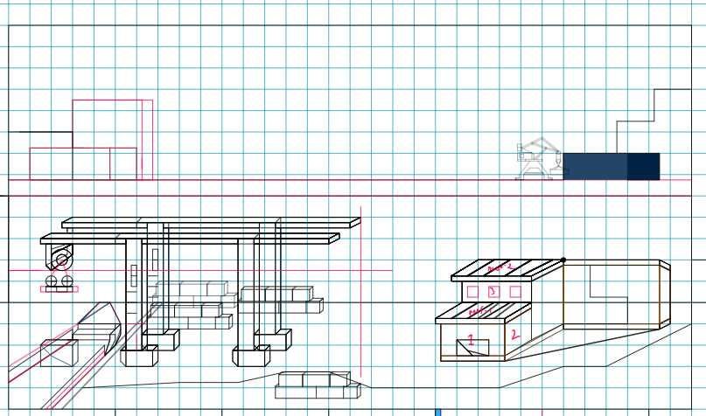

**Graph for City Scenario (scenario 2)**

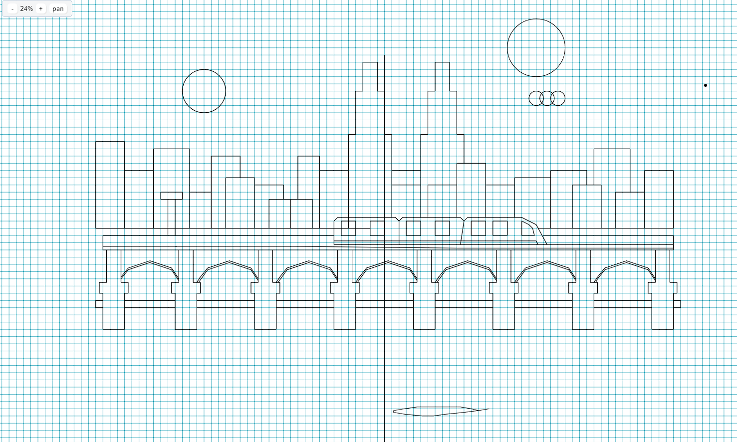

**

**Graph for water way (scenario 4)**

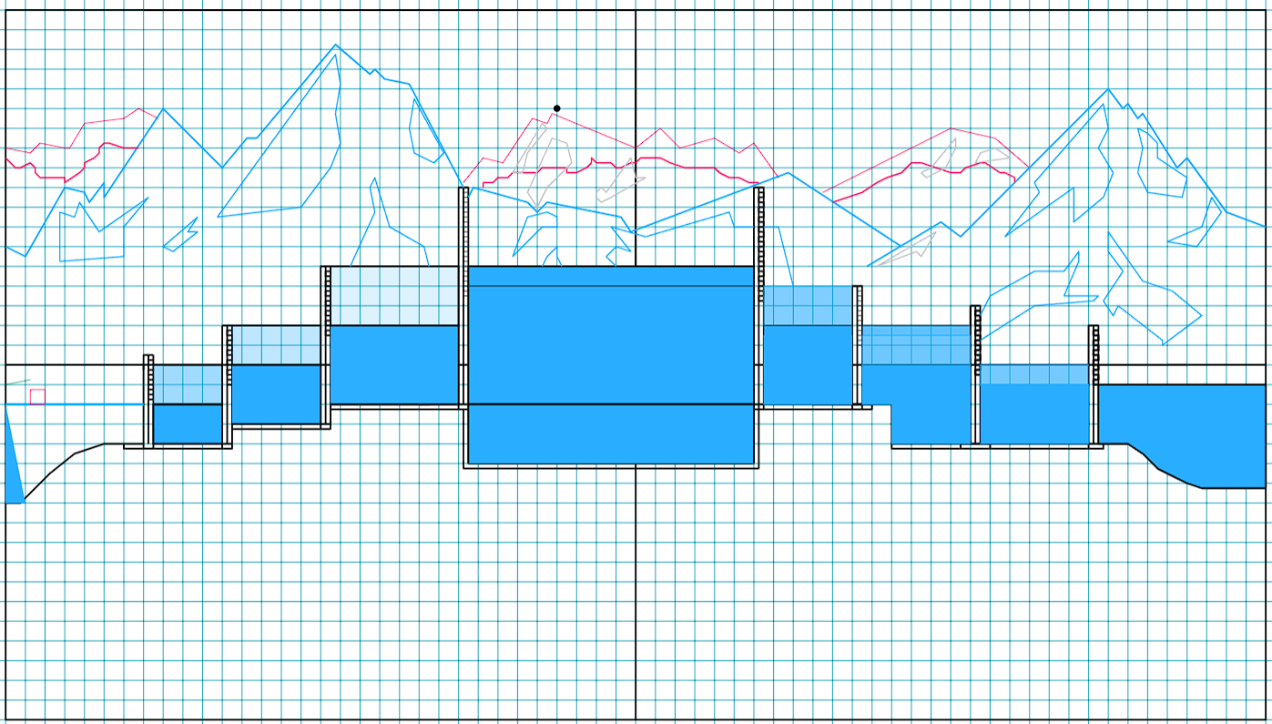

**List of Object**

1. List of objects assigning an object ID – Make a list of the objects that will be included in your project. MUST follow the following listing pattern.

|  |  |  |
| --- | --- | --- |
| SL# | Object ID | Object Name |
| 1 | sky_1 | Sky of Scenario 1 |
| 2 | Window_wh_1 | Window warehouse |
| 3 | Wh_door | Main Ware House door |
| 4 | Building_1 | Building Top Left |
| 5 | WareHouse1 | Building Top Right |
| 6 | Warehouse_2 | Main Ware House |
| 7 | Houses_1 | Background Building Right |
| 8 | Houses_2 | Background Building Left - Middle |
| 9 | Magnet | Magnet Part of Hook block |
| 10 | LineString | Load line |
| 11 | hook | Hook block |
| 12 | Crane1 | Front Crane |
| 13 | Crane2 | Back Crane |
| 14 | CraneBg_1 | CraneBackground |
| 15 | Sea_border_1 | Top sea border road/ line |
| 16 | Sea_1 | Sea |
| 17 | Road_1 | Road |
| 18 | containerModel_1 | Six container |
| 19 | Container_2 | Container Sea Side |
| 20 | Container_3 | Conatiner Front |
| 21 | Container_4 | Container On still ship_1 |
| 22 | Container5 | Container On ship_2 |
| 23 | Container6 | Container On ship Scenario 2 |
| 24 | Ship_1 | Load-Unload Ship |
| 25 | Ship_2 | Main Ship |
| 26 | Light_1 | Light on the ship |
| 27 | Truck_1 | Truck |
| 28 | circle | Circle |
| 29 | Cloud | Circle for CloudScene1 |
| 30 | CloudSet | CloudScene1 |
| 31 | streetlight | Street lights |
|  |  |  |
| 32 | skybackground | Sky scenario 2 |
| 33 | drawWater | Ocean scenario 2 |
| 34 | twintower | Twintower 2 |
| 35 | tempbuild | Back buildings 2 |
| 36 | drawBuilding | Front buildings 2 |
| 37 | stars | Stars for scenario 2 |
| 38 | bridgerail | Bridge for scenario 2 |
| 39 | buildingwindow | Building windows for 2 |
| 40 | buildingwindowtwo | Building windows 2 |
| 41 | drawbuildingL | All building scenario 2 |
| 42 | BridgeBox | Bridge pillars scenario 2 |
| 43 | trainLine | Train line for scenario 2 |
| 44 | BridgeRailing | Bridge pillars for scenario 2 |
| 45 | Full_train | Train for scenario 2 |
| 46 | Full_ship | Ship for scenario 2 |
| 47 | Full_cloud | Cloud for scenario 2 |
| 48 | Moon | Moon for scenario 2 |
| 49 | Sun | Sun for scenario 2 |
| 50 | Dew | Wave for scenario 2 |
|  |  |  |
| 51 | Sky_3 | Sky for scenario 4 |
| 52 | Sun_3 | Sun for scenario 4 |
| 53 | Back_mountain | Mountain (Back) |
| 54 | Front_mountain | Mountain (Front) |
| 55 | Gate_1 | First gate |
| 56 | Gate_2 | Second gate |
| 57 | Gate_3 | Third gate |
| 58 | Gate_4 | Fourth gate |
| 59 | Gate_5 | Fifth gate |
| 60 | Gate_6 | Sixth gate |
| 61 | Gate_7 | Seventh gate |
| 62 | Gate_8 | Eight gate |
| 63 | Canal_1 | First canal |
| 64 | Canal_2 | Second canal |
| 65 | Canal_3 | Third canal |
| 66 | Canal_4 | Fourth canal |
| 67 | Canal_5 | Fifth canal |
| 68 | Canal_6 | Sixth canal |
| 69 | Canal_7 | Seventh canal |
| 70 | Ground_3 | Ground for scenario 4 |
| 71 | Rock | Rocks for scenario 4 |
| 72 | Cloud_3 | Cloud for scenario 4 |
|  |  |  |
| 73 | sky_4 | Sky Scenario 3 |
| 74 | sea_4 | Sea Scenario 3 |
| 75 | seaSide | Sea Side sand Scenario 3 |
| 76 | Grass | Grass Scenario 3 |
| 77 | Shed | Shading Scenario 3 |
| 78 | MountainO | Mountain Scenario 3 |
| 79 | Boat | Boat Scenario 3 |
|  |  |  |

**List of Functions**

1. List of Functions To Represent Objects- Each object must be represented by a function. MUST follow the following listing pattern-

|  |  |  |
| --- | --- | --- |
| SL# | Object Name | Function Name |
| 1 | sky1 | sky_1 |
| 2 | Window warehouse | Window_wh_1 |
| 3 | Ware House door | Wh_door |
| 4 | Building Top Left | Building_1 |
| 5 | Building Top Right | WareHouse1 |
| 6 | Main Ware House | Warehouse_2 |
| 7 | Background Building Right | Houses_1 |
| 8 | Background Building Left - Middle | Houses_2 |
| 9 | Magnet Part of Hook | Magnet |
| 10 | Load Line | LineString |
| 11 | Hook body | hook |
| 12 | Front Crane | Crane1 |
| 13 | Back Crane | Crane2 |
| 14 | CraneBackground | CraneBg_1 |
| 15 | Top sea border road/ line | Sea_border_1 |
| 16 | Sea | Sea_1 |
| 17 | Road | Road_1 |
| 18 | Six container | containerModel_1 |
| 19 | Container Sea Side | Container_2 |
| 20 | Conatiner Front | Container_3 |
| 21 | Container On ship | Container_4 |
| 22 | Load-Unload Ship | Ship_1 |
| 23 | Main Ship | Ship_2 |
| 24 | Light on the ship | Light_1 |
| 25 | Truck | Truck_1 |
| 26 | Circle | circle |
| 27 | Cloud | Circle for CloudScene1 |
| 28 | CloudSet | CloudScene1 |
| 29 | streetlight | Street lights |
|  |  |  |
| 30 | Sky scenario 2 | skybackground |
| 31 | Ocean scenario 2 | drawWater |
| 32 | Twintower 2 | twintower |
| 33 | Back buildings 2 | tempbuild |
| 34 | Front buildings 2 | drawBuilding |
| 35 | Stars for scenario 2 | stars |
| 36 | Bridge for scenario 2 | bridgerail |
| 37 | Building windows for 2 | buildingwindow |
| 38 | Building windows 2 | buildingwindowtwo |
| 39 | All building scenario 2 | drawbuildingL |
| 40 | Bridge pillars scenario 2 | BridgeBox |
| 41 | Train line for scenario 2 | trainLine |
| 42 | Bridge pillars for scenario 2 | BridgeRailing |
| 43 | Train for scenario 2 | Full_train |
| 44 | Ship for scenario 2 | Full_ship |
| 45 | Cloud for scenario 2 | Full_cloud |
| 46 | Moon for scenario 2 | Moon() |
| 47 | Sun for scenario 2 | Sun() |
| 48 | Wave for scenario 2 | Dew() |
|  |  |  |
| 49 | Sky for scenario 4 | Sky_3 |
| 50 | Sun for scenario 4 | Sun_3 |
| 51 | Mountain (Back) | mountain_back |
| 52 | Mountain (Front) | mountain_front |
| 53 | First gate | First_gate |
| 54 | Second gate | second_gate |
| 55 | Third gate | third_gate |
| 56 | Fourth gate | fourth_gate |
| 57 | Fifth gate | Fifth_gate |
| 58 | Sixth gate | Sixth_gate |
| 59 | Seventh gate | Seventh_gate |
| 60 | Eight gate | Eight_gate |
| 61 | First canal | sewage_canal_1 |
| 62 | Second canal | sewage_canal_2 |
| 63 | Third canal | sewage_canal_3 |
| 64 | Fourth canal | sewage_canal_4 |
| 65 | Fifth canal | sewage_canal_5 |
| 66 | Sixth canal | sewage_canal_6 |
| 67 | Seventh canal | sewage_canal_7 |
| 68 | Ground for scenario 4 | ground_3 |
| 69 | Rocks for scenario 4 | rock_3 |
| 70 | Cloud for scenario 4 | Cloudset_4 |
| 71 | Moon for scenario 4 | Moon_3 |
| 72 | Snow for scenario 4 | Snows_3 |
| 73 | Snow storm | Snowstorm_3 |
| 74 | Ship for scenario 4 | Ship_3 |
|  |  |  |
| 75 | Sky Scenario 3 | sky_4 |
| 76 | Sea Scenario 3 | sea_4 |
| 77 | Sea Side sand Scenario 3 | seaSide |
| 78 | Grass Scenario 3 | Grass |
| 79 | Shading Scenario 3 | Shed |
| 80 | Mountain Scenario 3 | MountainO |
| 81 | Boat Scenario 3 | Boat |

1. List of Animation Functions with ID – These should be functions that are used to add animations like- object movement, mouse, and keyboard interaction, change of scenarios and so on. MUST follow the following listing pattern-

|  |  |  |  |
| --- | --- | --- | --- |
| SL# | Animation Function ID | Animation Function | Object/Scene |
| 1 | Magnet() |  | Crane 1 and Crane 2 |
| 2 | LineString() |  | Crane 1 and Crane 2 |
| 3 | shipAnimation() |  | Ship Animation Scenario 1 |
| 4 | CloudMovement() |  | Cloud Animation for Scenario 1 and 4 |
| 5 | truckMovement() |  | Truck Animation Scenario 1 |
| 6 | CraneKeyboard() |  | Keyboard to control Crane |
|  |  |  |  |
| 7 | update | update | Cloud and Wave |
| 8 | shipAnimation2() | shipAnimation2 | Ship and Train Animation S2 |
|  |  |  |  |
| 9 | Move ship1 | Void ship1(int value) | Move ship to canal 1 |
| 10 | Move ship2 | Void ship2(int value) | Move ship to canal 2 |
| 11 | Move ship3 | Void ship3(int value) | Move ship to canal 3 |
| 12 | Move ship4 | Void ship4(int value) | Move ship to canal 4 |
| 13 | Move ship5 | Void ship5(int value) | Move ship to canal 5 |
| 14 | Move ship6 | Void ship6(int value) | Move ship to canal 6 |
| 15 | Move ship7 | Void ship7(int value) | Move ship to canal 7 |
| 16 | Move ship8 | Void ship8(int value) | Move ship to water |
| 17 | Upgate1 | Void upgate1_up(int value) | Gate 1 open |
| 18 | Upgate2 | Void upgate2_up(int value) | Gate 2 open |
| 19 | Upgate3 | Void upgate3_up(int value) | Gate 3 open |
| 20 | Upgate4 | Void upgate4_up(int value) | Gate 4 open |
| 21 | Upgate5 | Void upgate5_up(int value) | Gate 5 open |
| 22 | Upgate6 | Void upgate6_up(int value) | Gate 6 open |
| 23 | Upgate7 | Void upgate7_up(int value) | Gate 7 open |
| 24 | Upgate8 | Void upgate8_up(int value) | Gate 8 open |
| 25 | Downgate1 | Void upgate1_down(int value) | Gate 1 close |
| 26 | Downgate 2 | Void upgate2_down(int value) | Gate 2 close |
| 27 | Downgate 3 | Void upgate3_down(int value) | Gate 3 close |
| 28 | Downgate 4 | Void upgate4_down(int value) | Gate 4 close |
| 29 | Downgate 5 | Void upgate5_down(int value) | Gate 5 close |
| 30 | Downgate 6 | Void upgate6_down(int value) | Gate 6 close |
| 31 | Downgate 7 | Void upgate7_down(int value) | Gate 7 close |
| 32 | Downgate 8 | Void upgate8_down(int value) | Gate 8 close |
| 33 | Canal1 up | Void canal1_up(int value) | Raise water level of Canal 1 |
| 34 | Canal2 up | Void canal2_up(int value) | Raise water level of Canal 2 |
| 35 | Canal3 up | Void canal3_up(int value) | Raise water level of Canal 3 |
| 36 | Canal5 down | Void canal5_up(int value) | Down water level of canal 5 |
| 37 | Canal6 down | Void canal6_up(int value) | Down water level of canal 6 |
| 38 | Canal7 down | Void canal7_up(int value) | Down water level of canal 7 |
| 39 | Snows_3 | Void snows_3() | Snow effects |
|  |  |  |  |
| 40 | shipAnimation3() | shipAnimation3() | Ship Animation S3 |

1. Contribution – This part will list the contribution of each member. MUST follow the following listing pattern-

|  |  |  |  |
| --- | --- | --- | --- |
| Member Name | Implemented Functions | Implemented Animation Functions | Percentage of Contribution |
| Rafsan Mahmud | Void ship1(int value)  Void ship2(int value)  Void ship3(int value)  Void ship4(int value)  Void ship5(int value)  Void ship6(int value)  Void ship7(int value)  Void ship8(int value)  Void set_color()  Void FIRST_GATE()  Void SECOND_GATE()  Void THIRD_GATE()  Void FOURTH_GATE()  Void FIFTH_GATE()  Void SIXTH_GATE()  Void SEVENTH_GATE()  Void EIGHTH_GATE()  Void sewage_canal_1()  Void sewage_canal_2()  Void sewage_canal_3()  Void sewage_canal_4()  Void sewage_canal_5()  Void sewage_canal_6()  Void sewage_canal_7()  Void upgate1_up(int value)  Void upgate2_up(int value)  Void upgate3_up(int value)  Void upgate4_up(int value)  Void upgate5_up(int value)  Void upgate6_up(int value)  Void upgate7_up(int value)  Void upgate8_up(int value)  Void upgate1_down(int value)  Void upgate2_down(int value)  Void upgate3_down(int value)  Void upgate4_down(int value)  Void upgate5_down(int value)  Void upgate6_down(int value)  Void upgate7_down(int value)  Void upgate8_down(int value)  Void canal1_up(int value)  Void canal2_up(int value)  Void canal3_up(int value)  Void canal4_up(int value)  Void canal5_up(int value)  Void canal6_up(int value)  Void canal7_up(int value)  Void sun_3()  Void moon_3()  Void snows_3()  Void cloudset_4()  Void snow_storm()  Void gate_snow()  Void mountain_front()  Void mountain_back()  Void sky_3()  Void sidewater()  Void ground_3()  Void rocks_3()  Void keyboard_raf()  Void display() | Void ship1(int value)  Void ship2(int value)  Void ship3(int value)  Void ship4(int value)  Void ship5(int value)  Void ship6(int value)  Void ship7(int value)  Void ship8(int value)  Void upgate1_up(int value)  Void upgate2_up(int value)  Void upgate3_up(int value)  Void upgate4_up(int value)  Void upgate5_up(int value)  Void upgate6_up(int value)  Void upgate7_up(int value)  Void upgate8_up(int value)  Void upgate1_down(int value)  Void upgate2_down(int value)  Void upgate3_down(int value)  Void upgate4_down(int value)  Void upgate5_down(int value)  Void upgate6_down(int value)  Void upgate7_down(int value)  Void upgate8_down(int value)  Void canal1_up(int value)  Void canal2_up(int value)  Void canal3_up(int value)  Void canal5_up(int value)  Void canal6_up(int value)  Void canal7_up(int value)  Void snows_3() | 25% |
| Ishtiak Billah Emon | set_color(string col)  streetlight()  More_StreetLight()  Circle(…)  sky_1()  Window_wh_1()  Adjust_Window()  Building_1()  Adjust_craneBg()  WareHouse_1()  Adjust_WareHouse1()  Houses_1()  Houses_2(string color)  Adjust_Houses_2()  Sea_border_1()  Sea_1()  Cloud(…)  CloudSet()  background_1()  road_design()  Road_1()  containerModel_1()  container_shadow()  Container_2()  Container_3()  Container_4()  Container5()  Container6()  Container7()  ship_shades()  Ship_1()  Light_1()  Adjust_light()  Adjust_ship()  Magnet()  LineString()  hook()  Crane1Design()  Crane1()  Crane2()  Wh_door()  Warehouse_shadow()  Warehouse_2()  Adjust_Truck()  background_2()  display1()  Cranekeyboard(int key, int x, int y)  shipAnimation(int value)  CloudMovement(int value)  truckMovement(int value)  display() | Magnet()  LineString()  Hook()  shipAnimation(int value)  CloudMovement(int value)  truckMovement(int value) | 25% |
| M Shahriar Alam Shajid | Sun()  Moon()  Dew()  adjust dew()  Full Dew()  Animation dew()  buildingwindow()  stars()  adjust stars()  buildingwindowtwo()  twintowerwindow()  bridgeBrike()  bridgenut()  drawBuilding()  drawBuildingL()  drawWater()  drawWaterNight()  skybackground()  BridgeBox()  BridgeBoxNight()  temp()  bridge()  tempbuilding()  twintower()  trainLine()  tempTrainLine()  BridgeRailing()  tempRail()  tempRailing()  drawTrainrail()  traindoor()  adjustdoor()  windowstrain()  adjustwindow()  reflect_windowstrain()  reflectwindow_night()  drawTrain()  railline2()  bridgerail()  adjustbridge()  ship()  Adjust_ship_shajid()  cloud()  adjust_cloud()  Full_cloud()  Animation_train()  update()  shipAnimation2()  display2() | update(int)  shipAnimation2(int value) | 25% |
| Atunu Saha | CraneBg_1()  Ship_2()  Truck_1()  sky_4()  sea_4()  seaSide()  Grass()  sun_atun(..)  Shed()  MountainO()  Boat()  Ship_Ocean()  adjustShip_S3()  display3()  shipAnimation3(int value) | shipAnimation3(int value) | 25% |

**Conclusion**

In concluding our computer graphics project, we've navigated through the intricacies of maritime simulation—from a bustling port to the tranquil waters of a canal. This journey showcases our team's adeptness in rendering realism through detailed ship design, dynamic water simulation, and immersive user interaction.

Facing and overcoming challenges, our project has not only honed technical skills but also emphasized the synergy between creativity and technology. The user's ability to interact adds depth to the visual experience, transforming it into a captivating digital voyage.

In essence, our project is a testament to the fusion of art and technology. It represents our dedication to excellence, innovation, and the creation of engaging digital narratives. As we bring this project to a close, we reflect on the skills acquired and the collaborative spirit that made this virtual maritime exploration a success.

**TECHNOLOGY’s USED**

1. OpenGL (Open Graphics Library):

• Rendering and Graphics: Utilized OpenGL for rendering realistic 2D graphics of ships, containers, buildings, bridges, trains, planes, and the environment.

• Shading and Lighting: Implemented shading techniques and lighting effects to create realistic day and night transitions, enhancing the visual appeal and immersion of each scenario.

2. GLUT (OpenGL Utility Toolkit):

• Windowing System: Employed GLUT for creating windows, handling user inputs (keyboard, mouse), and managing the overall application flow.

• Menu System: Utilized GLUT for implementing user interfaces and menus to control various aspects of the scenarios, such as controlling the crane, managing canal locks, adjusting weather settings, and controlling movable objects (ships, cars, trains, planes).

3. Object Movement and Interaction:

• User-Controlled Elements: Implemented ship movement, crane operations, and controlling other vehicles (cars, trains, planes) through user inputs, integrating functionalities to control and manipulate these objects within the scenarios.

4. Scenario-specific Features:

• Port Scenario: Implemented crane mechanism using interactive controls to load and unload containers from the ship, showcasing object manipulation and control.

• Urban Area Scenario: Created realistic urban environments featuring buildings, bridges, and trains, enhancing the immersive experience of navigating through an urban landscape.

• Canal Scenario: Developed a canal system with water level control and canal locks that allow the ship to ascend and descend, showcasing waterway management and navigation through challenging terrains.

5. Dynamic Weather:

• Day-Night Transition: Utilized OpenGL functionalities to dynamically transition between day and night environments, implementing lighting changes, skybox textures, and other visual effects to simulate realistic time changes.

6. Data Structures and Algorithms:

• Efficient Rendering: Utilized optimized data structures and algorithms to handle rendering large-scale environments and objects efficiently, ensuring smooth performance even with complex scenes.

7. Integration and Collaboration:

• Version Control: Potentially utilized version control systems (such as Git) for collaborative development, enabling multiple developers to work on different aspects of the project simultaneously.